



Leader: TIÊU HÀ ANH KHÔI CE140252

VÕ NHỰT HÀO CE140475

CHÂU HỮU ĐANG CE140529

Mentor: LƯƠNG HOÀNG HƯỚNG

Group 3

WEBSITE

SELLING SHOES

Project report



Table of Contents

CHAPTER 1 3

1.1 Problem Definition 3

1.2 User Requirements 4

1.2.1 Customer Requirement Specification 4

1.2.2 Hardware 7

1.2.3 Software 7

1.3 Project Detail 8

1.3.1 Date of project plan. 8

1.3.2 Project’s Vision/Objective 8

1.3.3 Project Initiation/ Requirement Document 8

1.3.4 Plan 8

1.4 Schedule and role 9

1.4.1 Role 9

1.4.2 Schedule 10

1.4.3 Gantt Diagram 11

1.5 Maintenance 12

1.5.1 Hourly maintenance package 12

1.5.2 Basic maintenance package: 12

1.5.3 Advanced maintenance package: 12

1.5.4 Professional maintenance package: 13

CHAPTER 2 15

2.1 Introduction to JSP 15

a. What is JSP? 15

b. Advantages of JSP over Servlet 15

c. The Lifecycle of a JSP Page 16

2.2 Introduction to MVC in JSP 17

a. What is MVC? 17

b. The advantages of MVC 17

c. The disavantages of MVC 17

CHAPTER 3 18

3.1 Architecture system 18

3.2 Use-case Diagram 19

3.3 Database Diagram 20

3.4 Class Diagram 21

21

3.5 Activity Diagram 22

a. User 22

b. Admin 23

3.5 DFD 24

**Data flow diagram symbol** 24

3.5.1 Contextual Level 0 25

3.5.2 Level 1 26

3.5.3 Level 2 28

3.5.4 Level 3 30

3.5.5 Level 4 31

3.5.6 Level 5 32

32

3.5.7 Level 6 33

33

CHAPTER 4: FUNCTIONS, USER INTERFACES AND FLOWCHART 34

4.1 Function 34

4.2 User Interfaces 35

4.3 Flowchart 52

CHAPTER 5: Consolution 53

5.1 The advantages of program: 53

5.1.1 About user: 53

5.1.2 About admin: 53

5.2 The disadvantages of program 53

5.3 Development direction of the project 53

# CHAPTER 1

## 1.1 Problem Definition

Most now if you want to buy shoes, you have to go to the store to buy them directly. Therefore, the following disadvantages are required:

* Store no branches in the area you live
* Lost too long time to search for shoe models
* Do not know the status of shoes are ready or not
* Risks when going out like robberies, accidents, ....

Therefore, we provide online sales solution on site with advantages such as:

Unlimited sales range

* The website is always open for sales
* Can check if the shoe model is ready or not
* Secure payment and many forms of payment
* Save time
* Easy to compare prices and product quality
* Avoid trouble when going out like traffic jam, weather, ..
* There are many discount vouchers

## User Requirements

### 1.2.1 Customer Requirement Specification

An intuitive sales website, which needs to be fast, full of consulting support tools and product customization, shipping solutions ... will help retailers to impress and build trust, Loyalty from customers. One of the factors that make up e-loyalty is the website of the seller. In order for customers to love and be loyal to their website, sales people must make a first impression. The superior features, customer-oriented design will make them feel satisfied and appreciate that site.

First of all, e-commerce website must be designed specifically for customers who have shopping goals. From the color, the layout of the website, the ability to navigate, the content of the article, images, videos of the product, the reviews, comments of experts and customers about the product ... all must focus on the episode targeted customer. Second, salespeople need to understand that customers often surf the web for a short time and wait is somewhat limited. If an e-commerce website takes a long time to load a page, customers may be frustrated, not interested in accessing and shutting down the browser. In addition, the website's navigation must also be convenient, present clear and coherent indexes, allowing customers to find products easily, quickly and accurately.

The second element is customer service (the support activities before-during-after the purchase process of the seller). Good, breakthrough service in the market will help create competitive power and increase customer loyalty when buying online. Shoppers pay much attention to policies such as allowing for return, warranty, incentives as well as support solutions, the process of executing and delivering orders quickly and accurately with many shipping solutions.

Allowing to customize products according to each customer's unique requirements and quick, instant interaction are two values ​​that make the website easy to win good feelings and customer loyalty when buying online. gland. According to market research firm Forester Research, most online shoppers want e-commerce websites that have a feature that allows them to customize products and information for each customer.

Customizing products as you like is the result of the interaction process between customers and sellers in making detailed requirements about a specific product or service. Allowing customers to actively participate in designing their products according to their needs creates a strong and impressive effect in the relationship between sellers and customers. This is an important basis for brand loyal customers.

For example, Dell Computer Corporation allows buyers to choose the configuration, components, colors for their computers. Swedish furniture IKEA lets customers design their own furniture on the website. If the website does not sell customized products or does not have this feature, it can increase the value of soft products such as diverse products, designs, rich prices, suitable for many customers, construction. Convenient and groundbreaking sales services in the market ...

The Internet environment is always risky, so reliability and security are factors that create the love and loyalty of customers in the online marketing environment. This is also the difference between e-commerce and traditional commerce. Studies and practices show that customers are always afraid of revealing personal information and having their credit card accounts stolen, one of the basic reasons why they are hesitant to participate in the business. online.

With the Internet, branding is often associated with the domain name of the website, this time as an extension of the concept of the brand. For example, when it comes to Amazon e-retailer brand, customers often associate with Amazon.com website and other local websites of Amazon company such as Amazon.de (Germany), Amazon.jp (Japan). copy).

Of course, customers may not always know or even remember the websites of famous brands or products, but the content and features of the website always play a very important role. in building customer loyalty in an ecommerce marketing environment.

### 1.2.2 Hardware

|  |  |
| --- | --- |
| **Hardware Requirement**  **(Minimum)** | **Hardware Requirement**  **(Recommended)** |
| **+ CPU:** Intel Pentium 2 266 MHz  **+ RAM:** 1 GB  **+ Storage:** 1GB of free disk space | **+ CPU:** Intel Core i3 10110U  **+ RAM:** 4 GB  **+ Storage:** 1GB of free disk space |

### 1.2.3 Software

|  |
| --- |
| **Software Requirement** |
| + Window 7 or higher  + Web browser |

## 1.3 Project Detail

### 1.3.1 Date of project plan.

Start: May 25th ,2020

End: July 20th, 2020

### 1.3.2 Project’s Vision/Objective

The goal of this project is to create a website that sells shoes online.

### 1.3.3 Project Initiation/ Requirement Document

* + - Product information
    - Services information of company.
    - Deliverables
    - CRS document
    - Design document
    - User Manual
    - Maintenance Manual
    - Code document (if client require)

### 1.3.4 Plan

1. Review activities: Review 2 times in classroom.
2. Testing activities: Test code, test web after done
3. Demo activities: Demo 1 time in classroom
4. Backup and recovery at Github

- Major project milestones:

* Definition problem from 25/5/2020 to 29/5/2020
* User requirement from 29/5/2020 to 3/6/2020
* Analysis from 3/6/2020 to 20/6/2020
* Design from 20/6/2020 to 28/6/2020
* Coding from 28/6/2020 to 8/7/2020
* Testing from 8/7/2020 to 19/7/2020
* Maintenance from 19/7/2020 to 20/7/2020

## 1.4 Schedule and role

### 1.4.1 Role

|  |  |  |  |
| --- | --- | --- | --- |
| **No** | **Role** | **Member** | **Responsibilities** |
| 1 | Leader | KhoiTHA | Creating Schedule and Check List, Assigning assignment to team members |
| 2 | Secretary | DangCH | Taking note |
| 3 | Analyst & Design | KhoiTHA, HaoVH, DangCH | Table of content, Define problem, Design w interface |
| 4 | Coder | KhoiTHA, HaoVH, DangCH | Program all functions |
| 5 | Tester | KhoiTHA, HaoVH, DangCH | Testing |
| 6 | Maintenance | KhoiTHA, HaoVH | Checking and backup data |

### 1.4.2 Schedule

|  |  |  |  |  |  |
| --- | --- | --- | --- | --- | --- |
| Task no. | Task description | Expected start date | Expected completion date | Expected  Time needed  (hrs) | Status |
| 1 | Design ideas | 5/25/2020 | 5/29/2020 | 4 | **Done** |
| 2 | Planing | 5/29/2020 | 6/2/2020 | 5 | **Done** |
| 3 | Draw gantt diagram | 6/2/2020 | 6/3/2020 | 1 | **Done** |
| 4 | Functional web analysis | 6/3/2020 | 6/20/2020 | 18 | **Done** |
| 5 | Main module analysis | 6/3/2020 | 6/7/2020 | 5 | **Done** |
| 6 | Sub module analysis | 6/7/2020 | 6/15/2020 | 9 | **Done** |
| 7 | Database diagram | 6/15/2020 | 6/20/2020 | 6 | **Done** |
| 8 | Create database | 6/20/2020 | 6/23/2020 | 4 | **Done** |
| 9 | Coding main module | 6/23/2020 | 6/25/2020 | 3 | **Done** |
| 10 | Coding sub module | 6/28/2020 | 7/3/2020 | 6 | **Done** |
| 11 | Design front-end | 7/3/2020 | 7/8/2020 | 6 | **Done** |
| 12 | Test main module | 7/8/2020 | 7/15/2020 | 8 | **Done** |
| 13 | Test sub module | 7/15/2020 | 7/18/2020 | 4 | **Done** |
| 14 | Install on server | 7/18/2020 | 7/19/2020 | 2 | **Done** |

### 1.4.3 Gantt Diagram

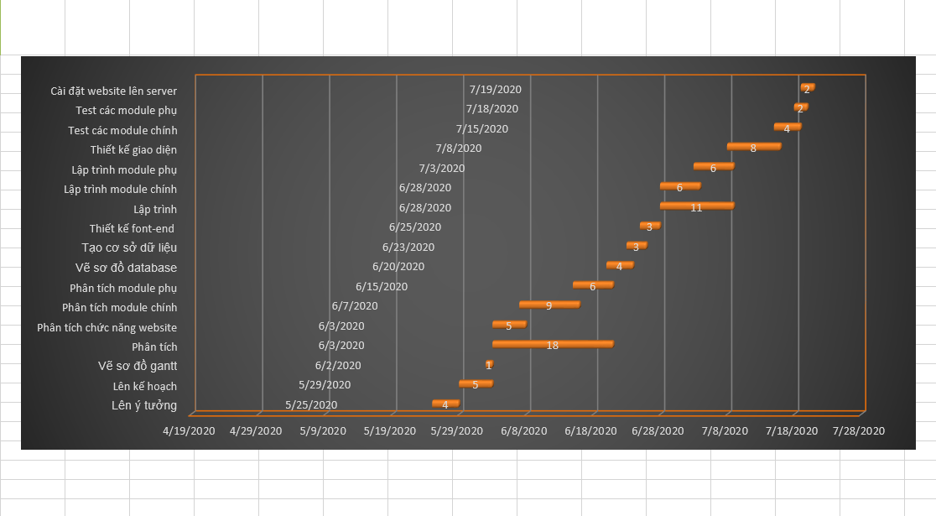

## 1.5 Maintenance

### 1.5.1 Hourly maintenance package

ICSC offers a flexible hourly maintenance service package for businesses that already have a website admin but in a certain period of time, need the assistance of a company specializing in information technology to overcome. Incidents, data recovery or website upgrades according to each company's promotions. The cost for this package is 500,000 VND / 1 working hour.

1.5.2 Basic maintenance package: 700,000 VND / month including the following specific jobs:

- Edit images, article content in the month. Time: 1 - 2 hours

- Update website content according to customer requirements

- Upload data via the FTP protocol

- Promptly respond to requests for change or troubleshooting upon receipt of a notice

- Edit the error links in the website

- Store website data monthly.

1.5.3 Advanced maintenance package: 1,500,000 VND / month including the following specific jobs:

- Edit images, article content in the month. Time: 5 hours

- Update website content according to customer requirements

- Download data via the FTP protocol

- Promptly respond to requests for change or troubleshooting upon receipt of a notice

- Edit the error links in the website

- Store website data weekly.

1.5.4 Professional maintenance package: 5,000,000 VND / month including the following specific jobs:

- Edit images, article content in the month. Time: 10 hours

- Update website content according to customer requirements, including product updates for the E-commerce website

- Download data via the FTP protocol

- Promptly respond to requests for change or troubleshooting upon receipt of a notice

- Edit the error links in the website

- Store website data weekly.

# CHAPTER 2

## 2.1 Introduction to JSP

### What is JSP?

* JSP technology is used to create web application just like Servlet technology. It can be thought of as an extension to Servlet because it provides more functionality than servlet such as expression language, JSTL, etc.
* A JSP page consists of HTML tags and JSP tags. The JSP pages are easier to maintain than Servlet because we can separate designing and development. It provides some additional features such as Expression Language, Custom Tags, etc.

### Advantages of JSP over Servlet

* Extension to Servlet: JSP technology is the extension to Servlet technology. We can use all the features of the Servlet in JSP. In addition to, we can use implicit objects, predefined tags, expression language and Custom tags in JSP, that makes JSP development easy.
* Easy to maintain: JSP can be easily managed because we can easily separate our business logic with presentation logic. In Servlet technology, we mix our business logic with the presentation logic.
* Fast Development: No need to recompile and redeploy. If JSP page is modified, we don't need to recompile and redeploy the project. The Servlet code needs to be updated and recompiled if we have to change the look and feel of the application.
* Less code than Servlet: In JSP, we can use many tags such as action tags, JSTL, custom tags, etc. that reduces the code. Moreover, we can use EL, implicit objects, etc.

### The Lifecycle of a JSP Page

* Translation of JSP Page
* Compilation of JSP Page
* Classloading (the classloader loads class file)
* Instantiation (Object of the Generated Servlet is created).
* Initialization (the container invokes jspInit() method).
* Request processing (the container invokes _jspService() method).
* Destroy (the container invokes jspDestroy() method).
* As depicted in the above diagram, JSP page is translated into Servlet by the help of JSP translator. The JSP translator is a part of the web server which is responsible for translating the JSP page into Servlet. After that, Servlet page is compiled by the compiler and gets converted into the class file. Moreover, all the processes that happen in Servlet are performed on JSP later like initialization, committing response to the browser and destroy.

## 2.2 Introduction to MVC in JSP

### What is MVC?

*Model - View - Controller (MVC)* is a design model aimed at splitting the Interface and Code sections for ease of management, development and maintenance. MVC divides the software application into 3 parts that interact with each other: Model (Data), View (Interface), Controller (Code that controls the interaction between Model and View as well as business (Business)).

* *Model Layer:*

Represents the state (data), and is the lowest layer in the sample. It responds to requests from the view and it also responds to directives from the controller to update itself.

* *View Layer:*

Responsible for displaying data in a specific format.

* *Controller Layer:*

Acting as an Interface interface between View and Model. It intercepts and is responsible for responding to all requests (receiving inputs and commands) to the Model / View to perform the corresponding interactions. The controller receives input, it performs validation and then performs operations that modify the state of the Model.

### The advantages of MVC

Demonstrate professionalism in programming and object analysis, because it is divided into separate components, so the independent operation makes application development faster, simpler, and easier to upgrade and maintain.

### The disavantages of MVC

As a very methodical working model, with small applications, using MVC is very time-consuming and causes a lot of complexity.

# CHAPTER 3

## 3.1 Architecture system

Figure 1: Architecture Diagram

## 3.2 Use-case Diagram

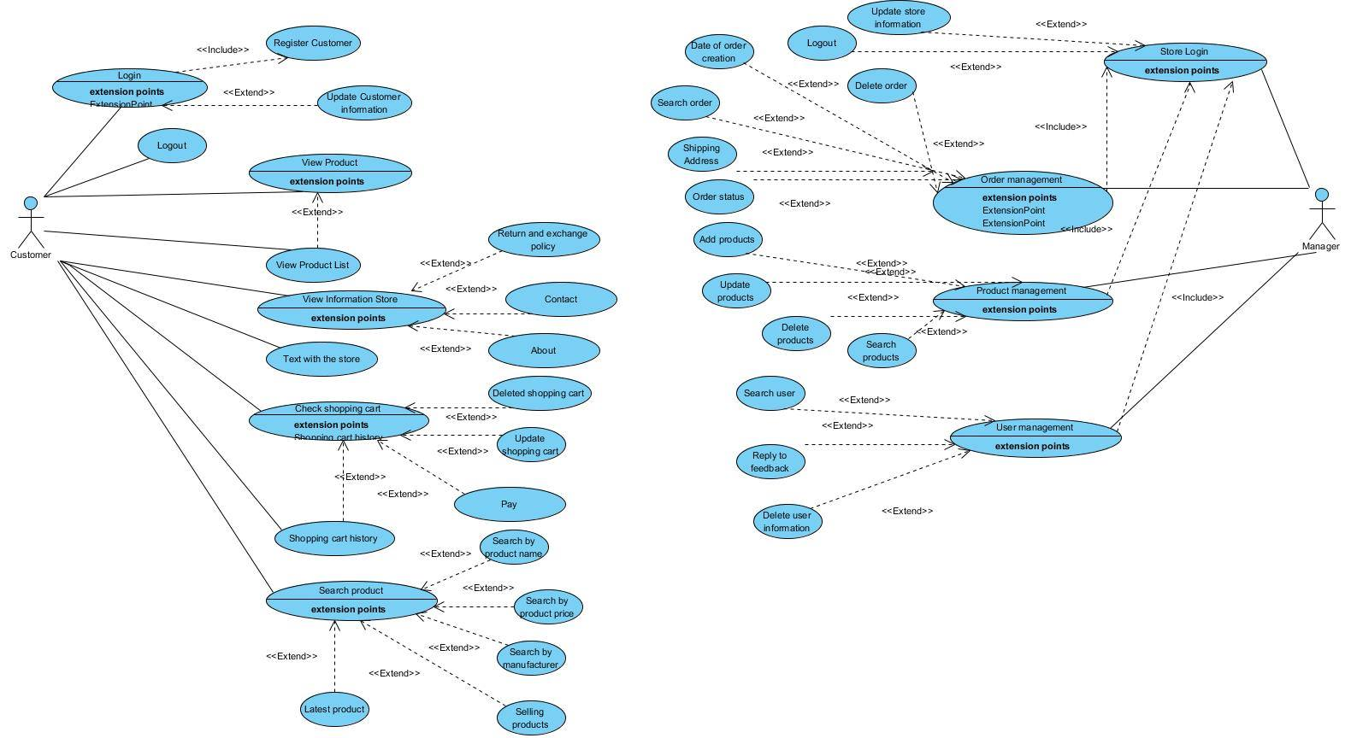

Figure 2: Use-case Diagram

## 3.3 Database Diagram

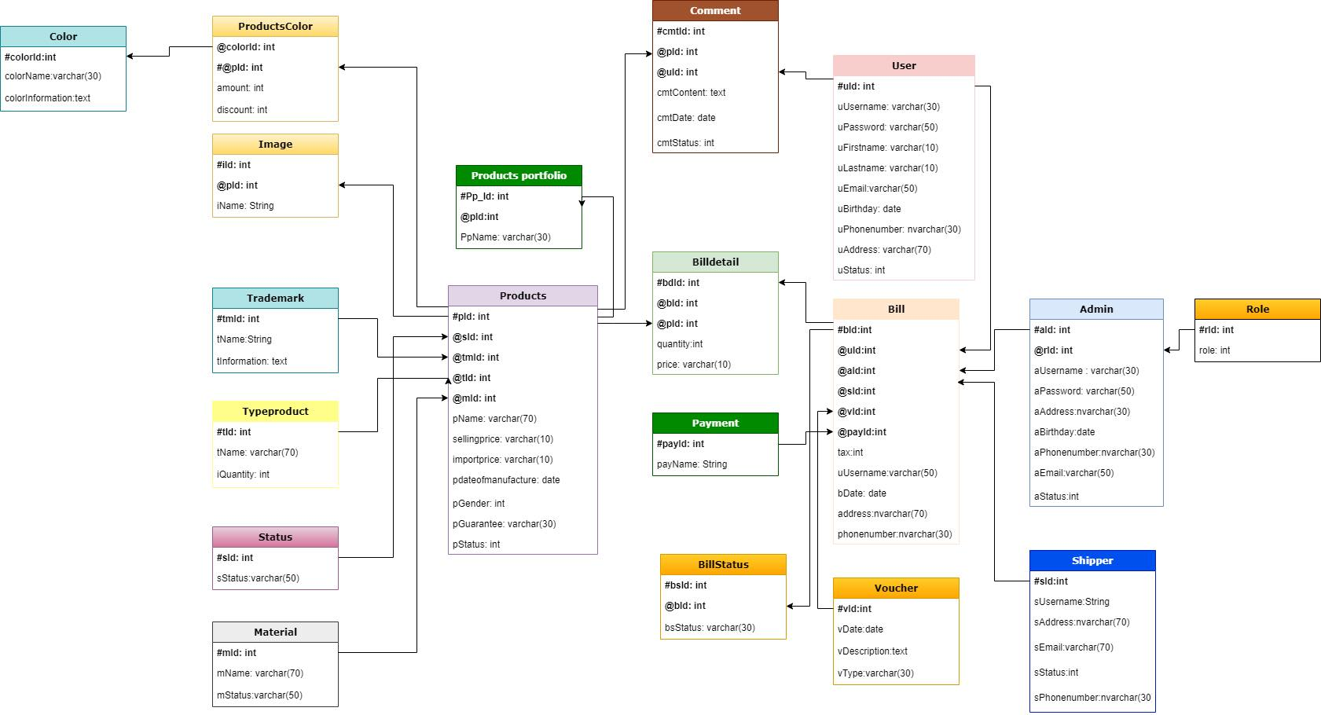

Figure 3: Database Diagram

## 3.4 Class Diagram

## 

Figure 4: Class Diagram

## 3.5 Activity Diagram

### a. User

Figure 5: User Diagram

### b. Admin

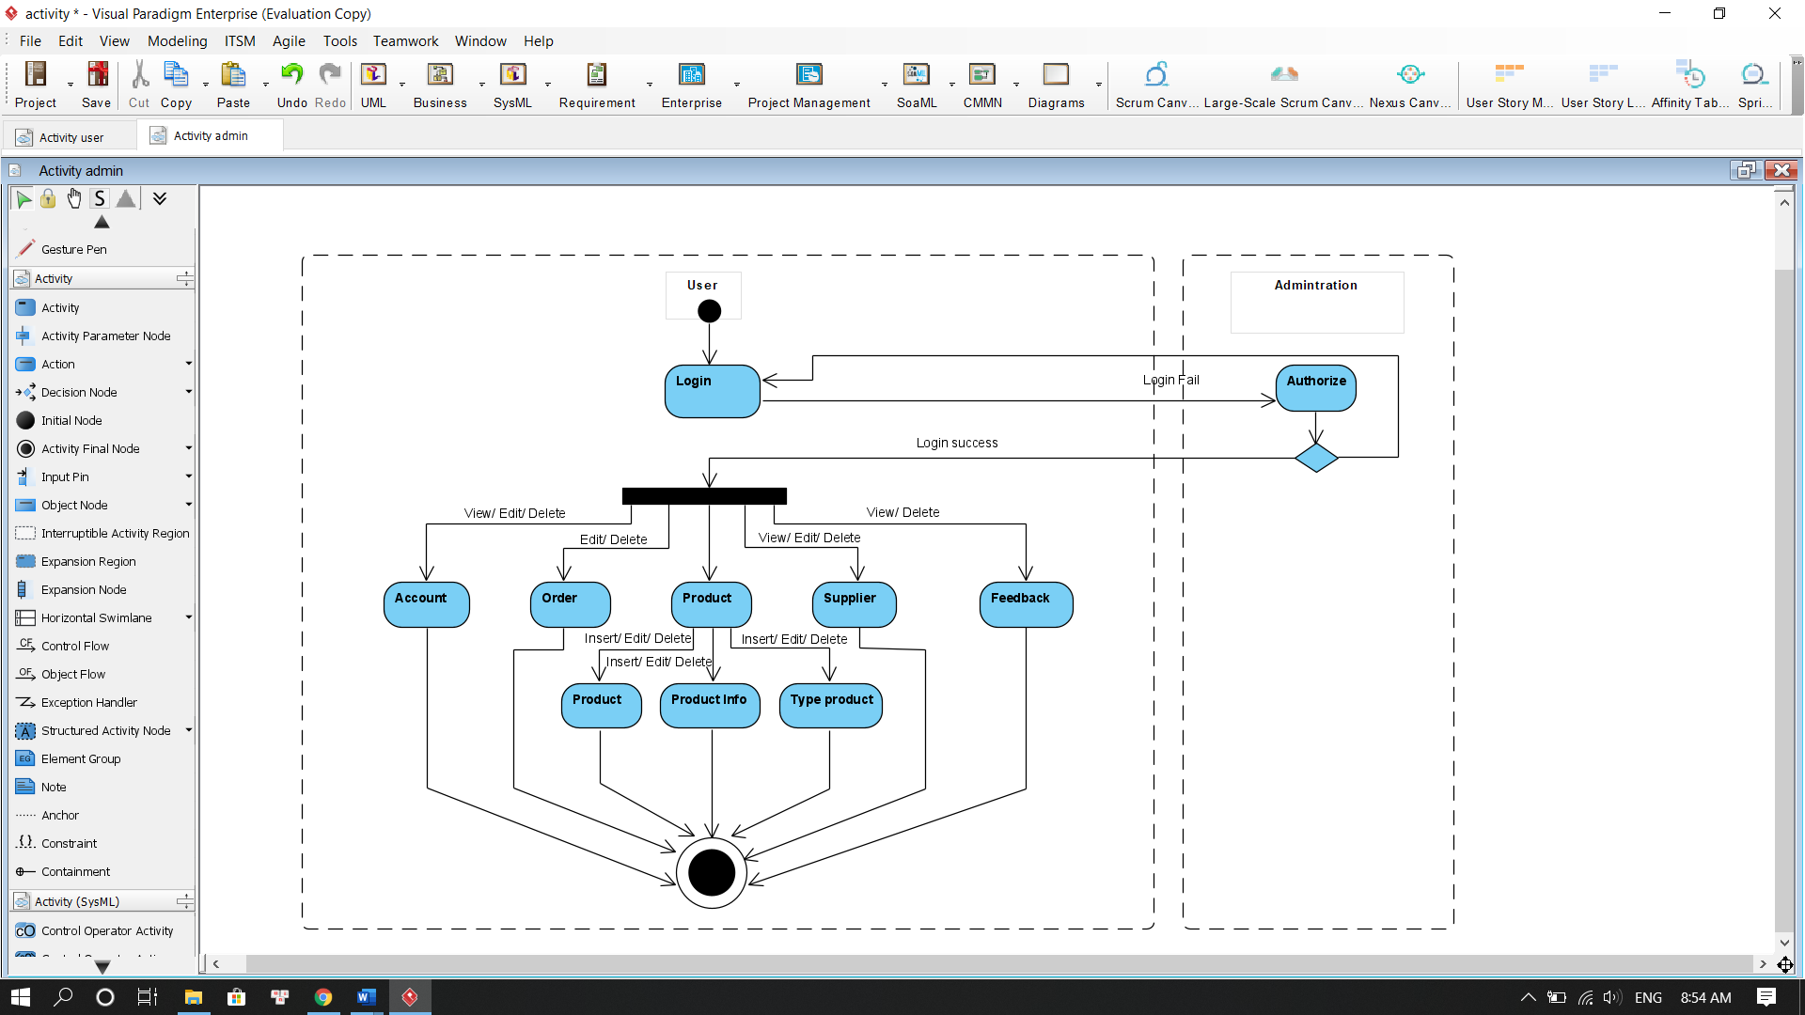

Figure 6: Adminr Diagram

## DFD

**Data flow diagram symbol**

|  |  |
| --- | --- |
| Symbol | Description |
|  | **Data Flow:** Data flow are pipelines through the packets of information flow. |
|  | **Process:** A Process or task performed by the system. |
|  | **Entity:** Entity are object of the system. A source or destination data of a system. |
|  | **Data Store:** A place where data to be stored. |

### 3.5.1 Contextual Level 0

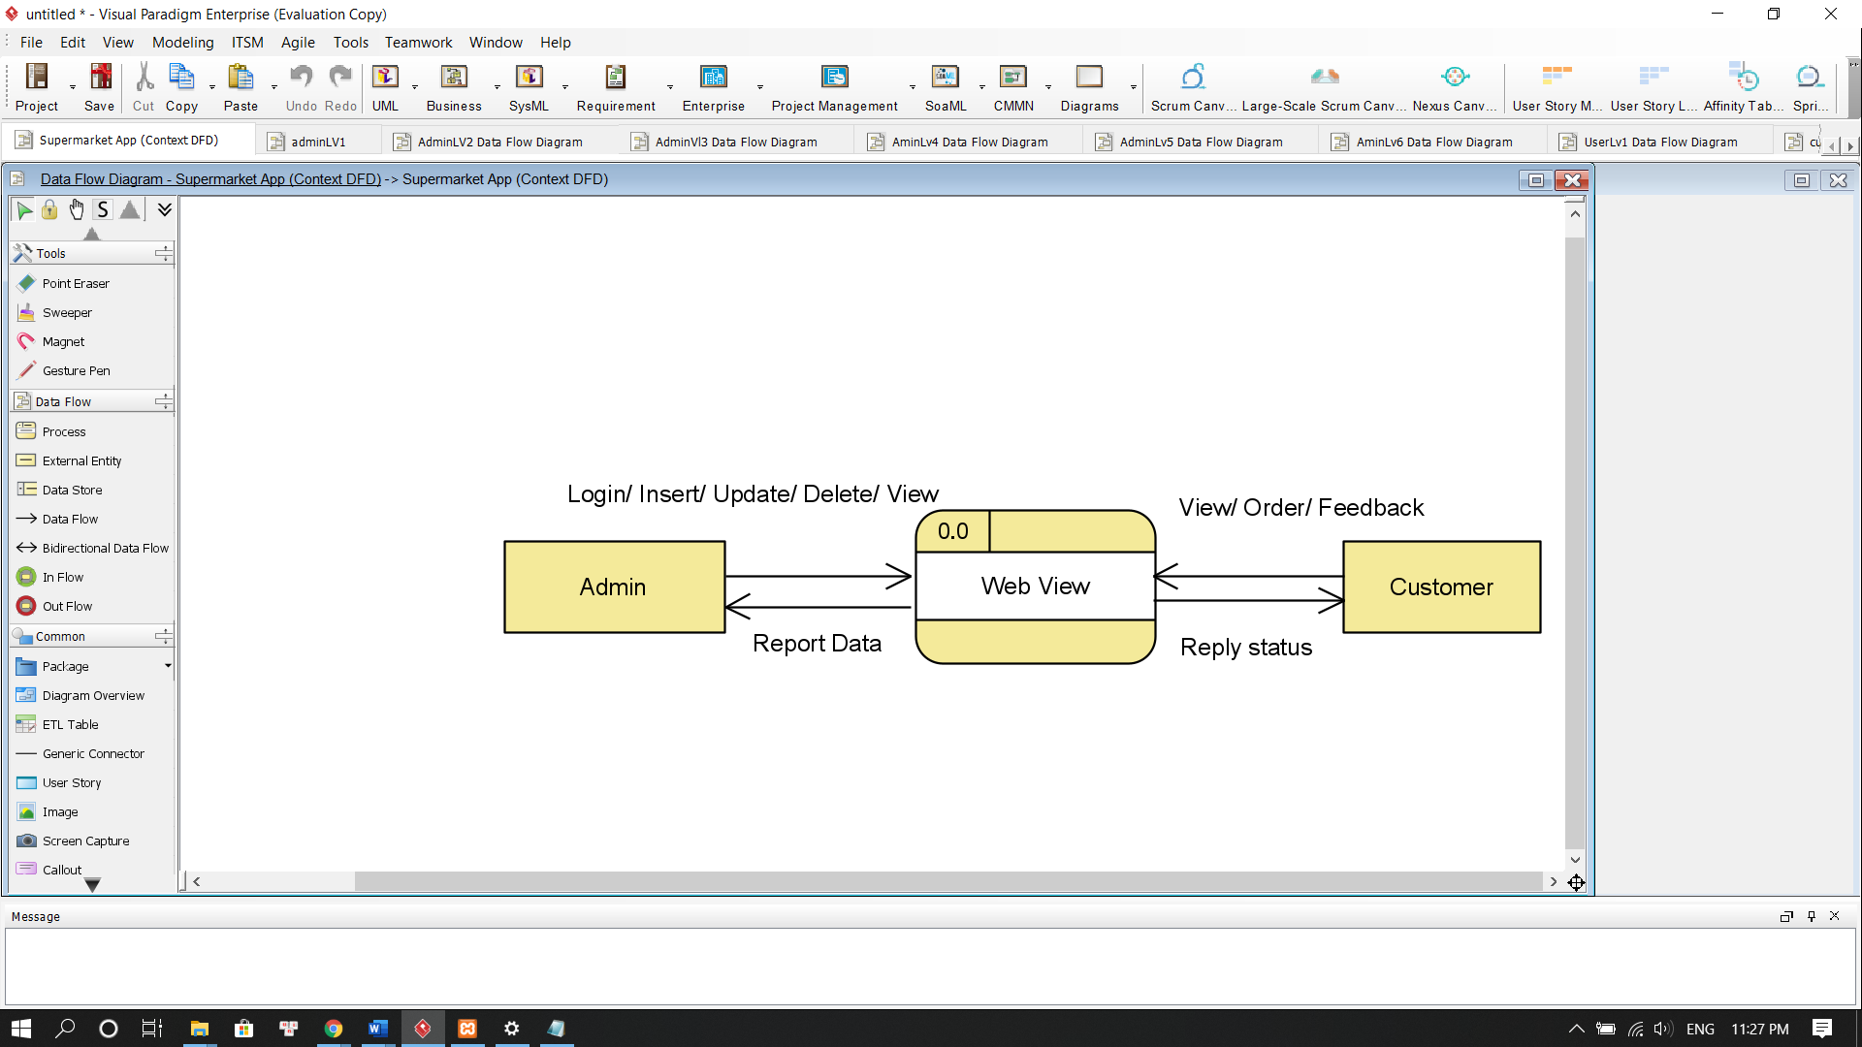

Figure 7: Contextual Level 0 Diagram

### 3.5.2 Level 1

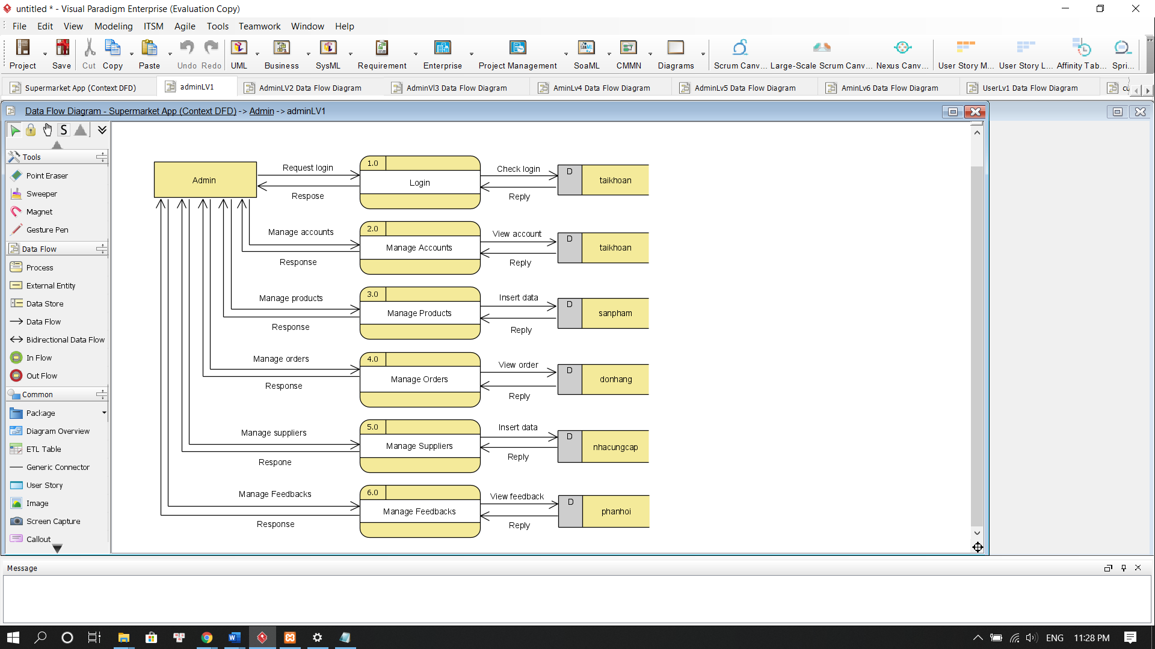

Figure 8: Admin Lv1 Diagram

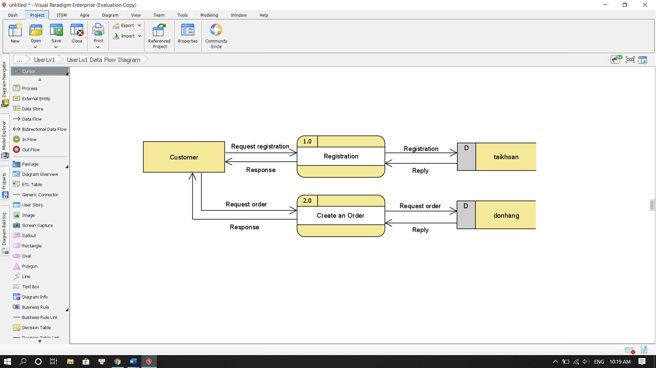

Figure 9: Customer Lv1 Diagram

### 3.5.3 Level 2

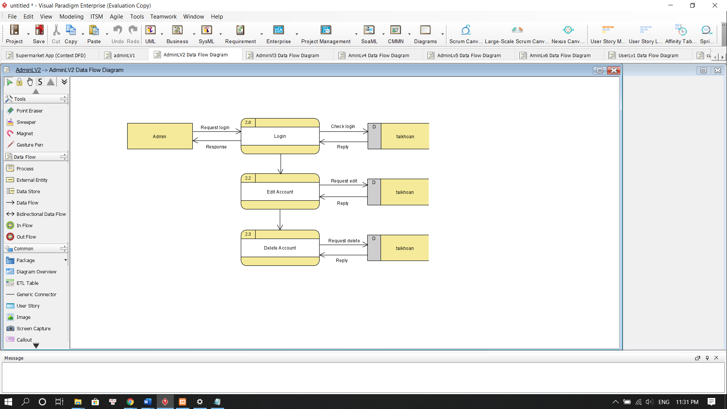

Figure 10: Admin Lv2 Diagram

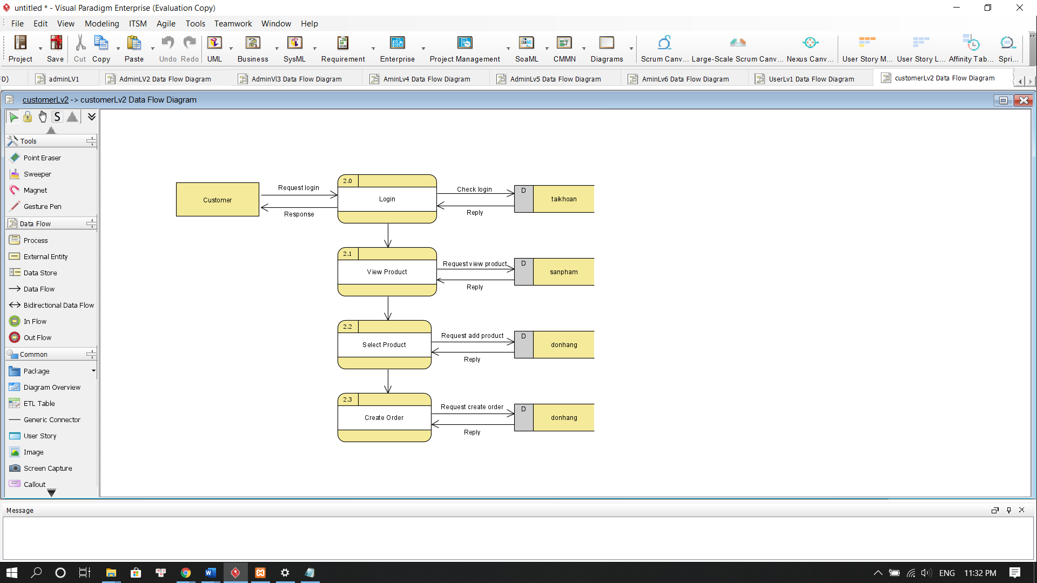

Figure 11: Customer Lv2 Diagram

### 3.5.4 Level 3

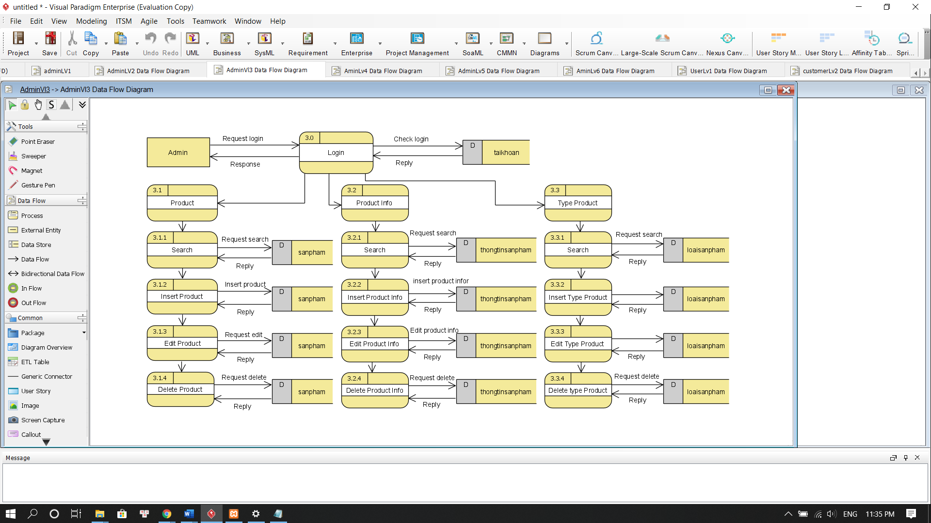

Figure 12: Admin Lv3 Diagram

### 3.5.5 Level 4

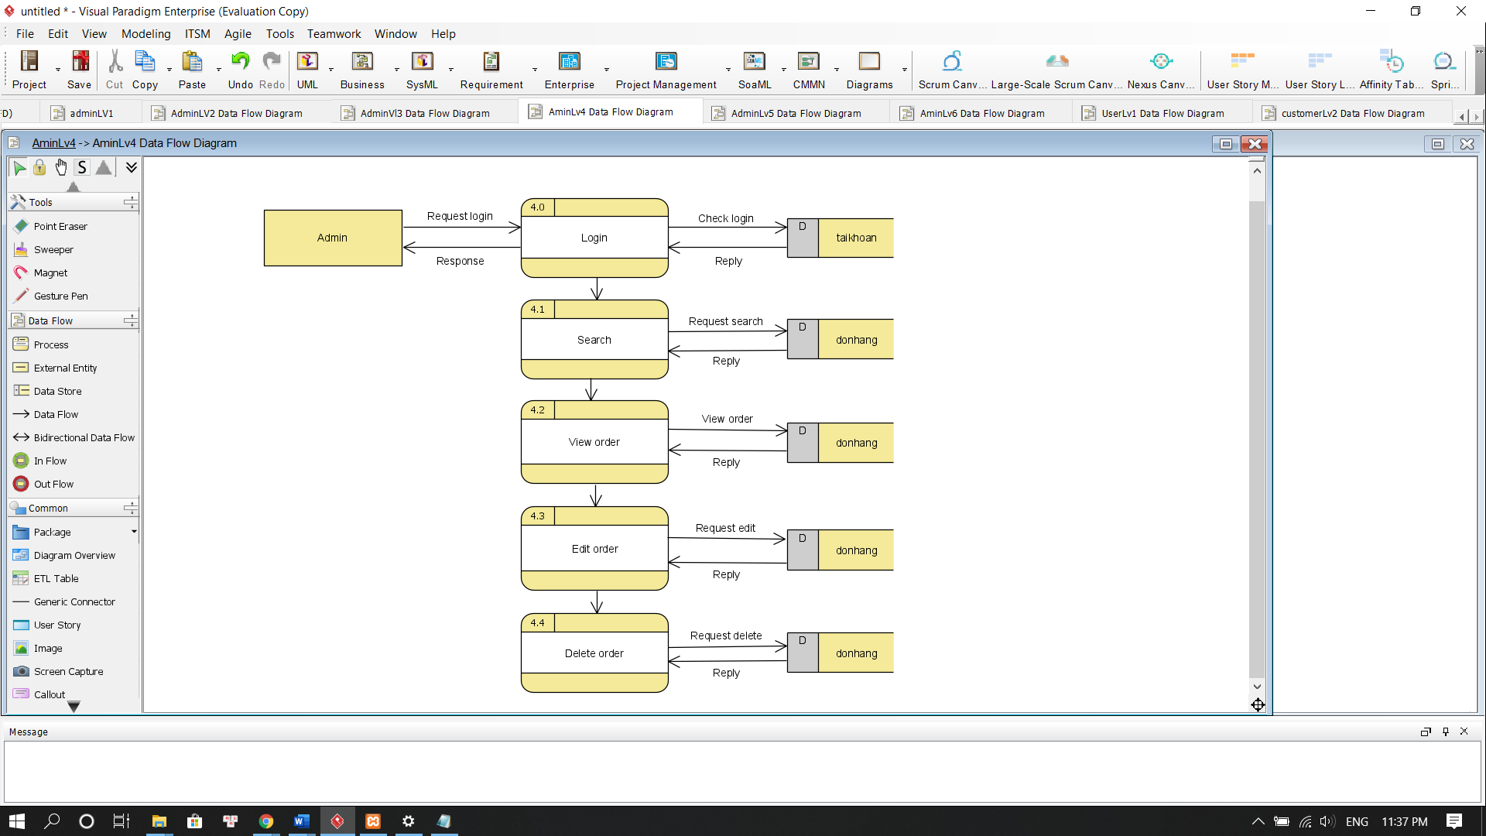

Figure 13: Admin Lv4 Diagram

### 3.5.6 Level 5

### 

Figure 14: Admin Lv5 Diagram

### 3.5.7 Level 6

### 

Figure 15: Admin Lv6 Diagram

# CHAPTER 4: FUNCTIONS, USER INTERFACES AND FLOWCHART

## Function

* + Login
  + Register
  + Logout
  + Add product
  + Update product
  + Delete product
  + Sort product with name from A to Z
  + Sort product with increase price
  + Sort product with decrease price
  + Search product
  + Add to cart
  + Show product with the same price
  + Show product with the same series
  + Search product by name
  + Search product by discount

## 4.2 User Interfaces

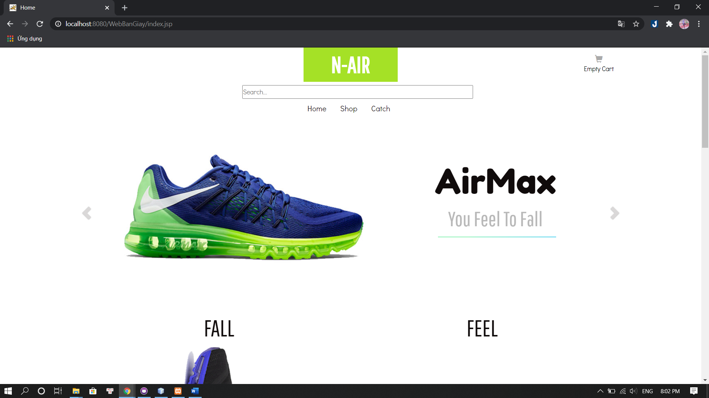

Figure 16: User- Home

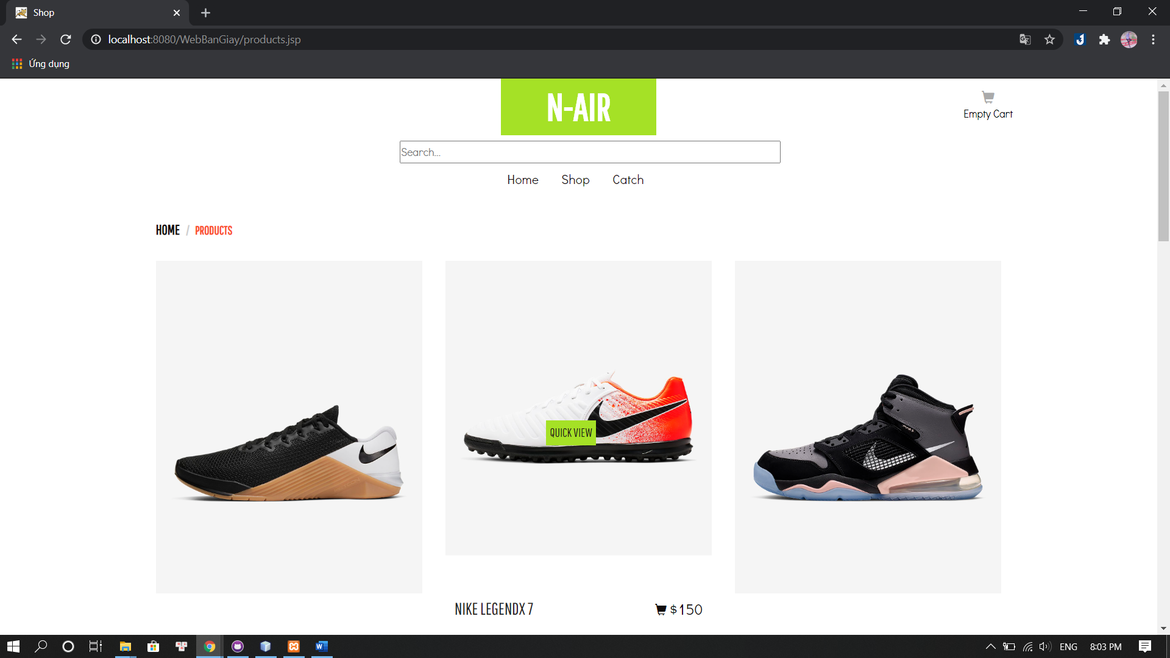

Figure 17: User- Shop

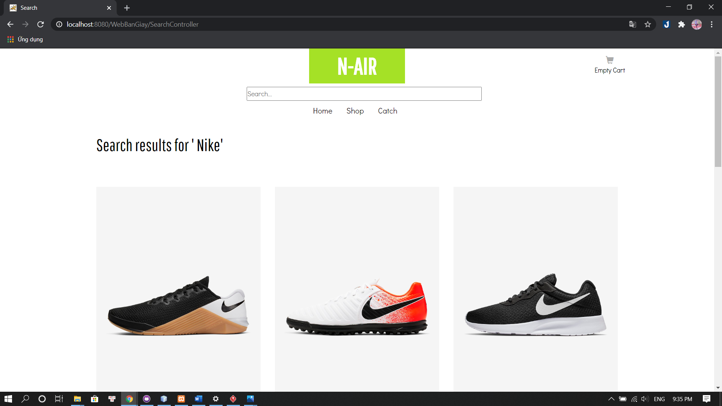

Figure 18: User- Search Product

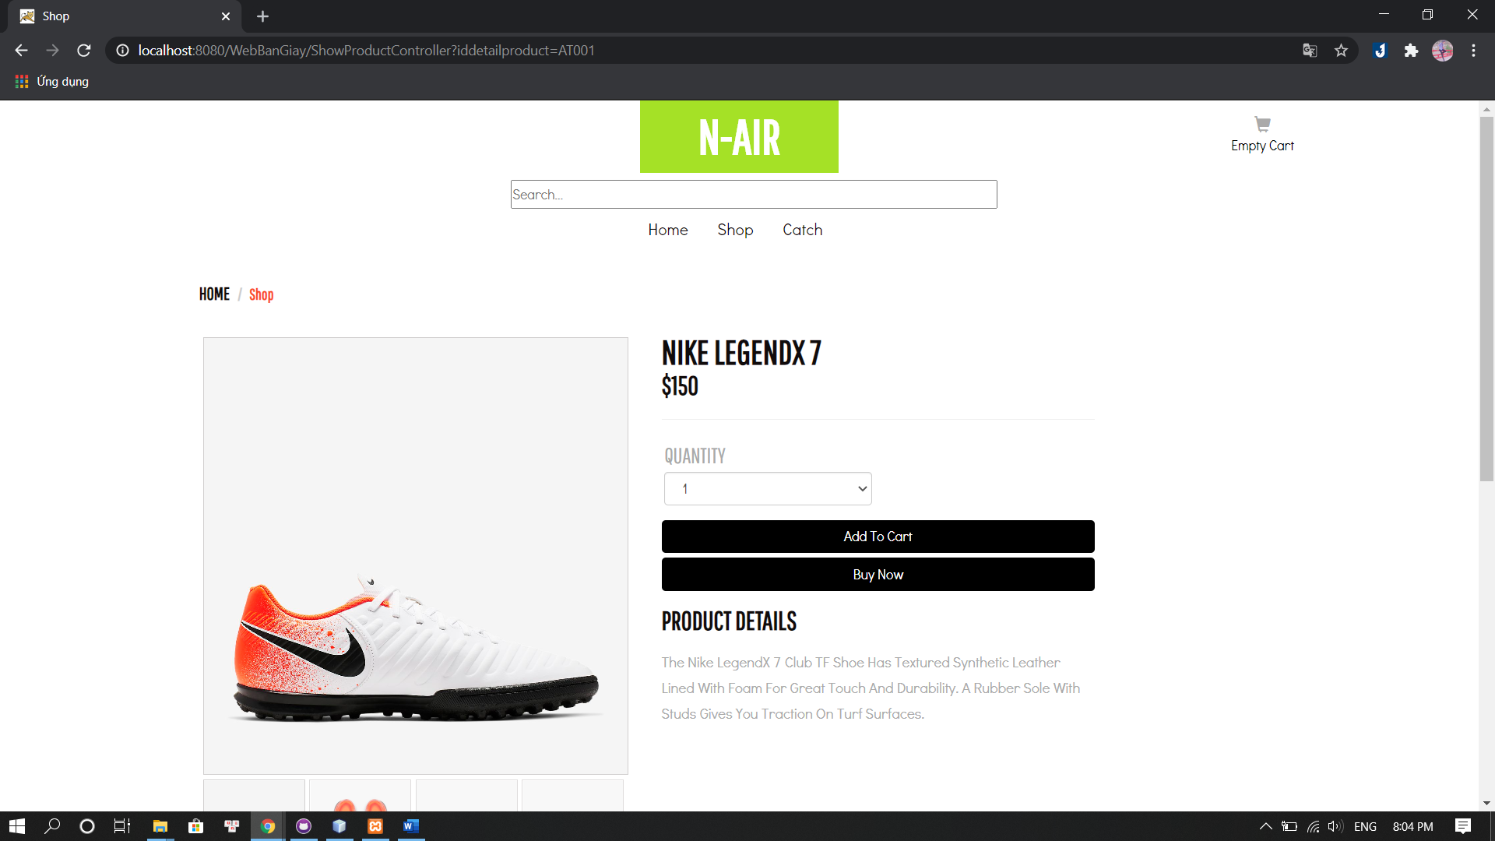

Figure 19: User- Product Detail

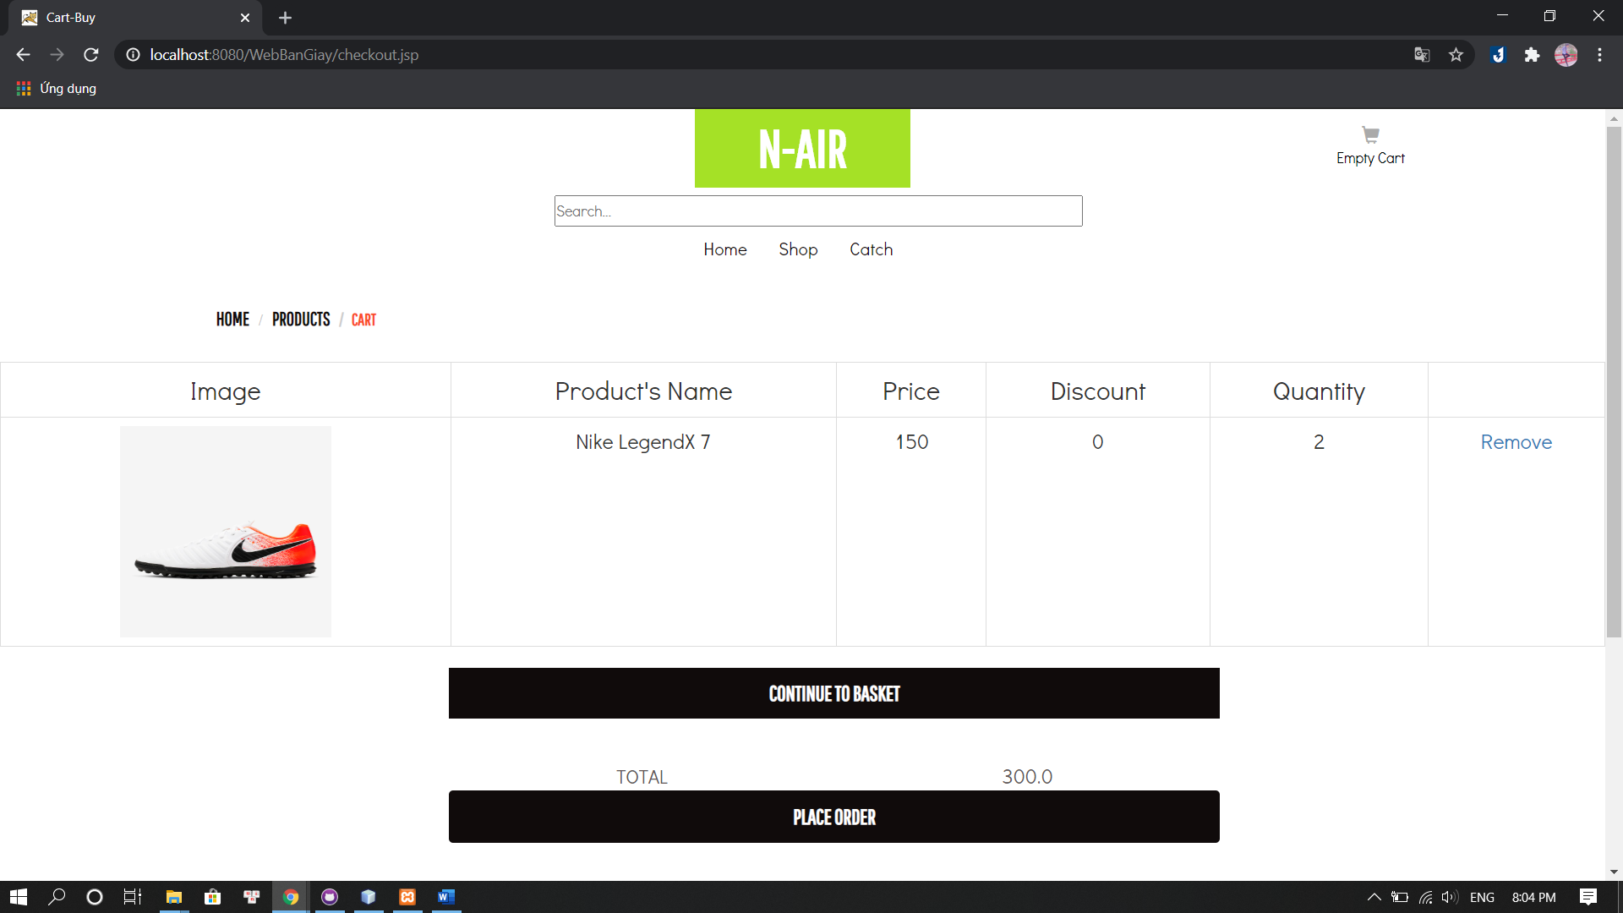

Figure 20: User- Cartl

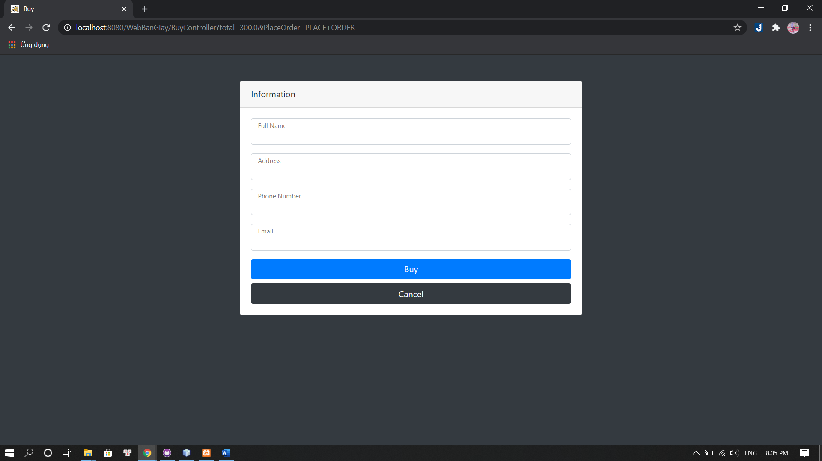

Figure 21: User- Order Information

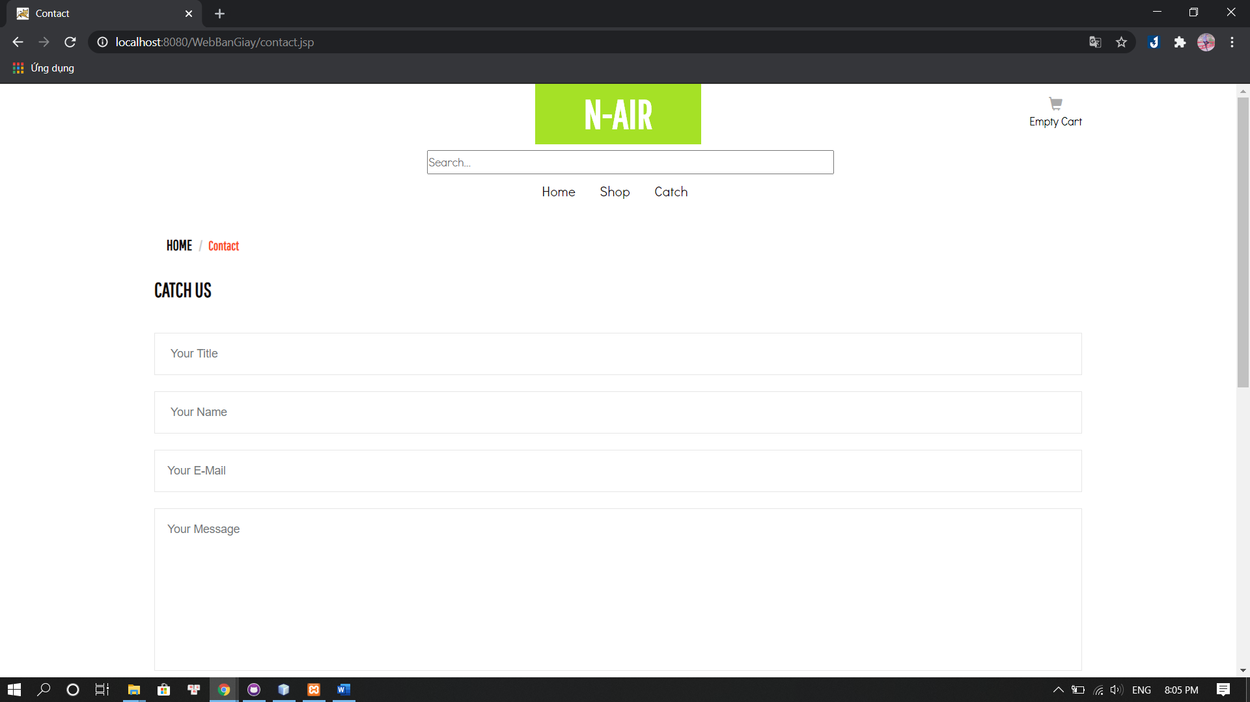

Figure 22: User- Contact

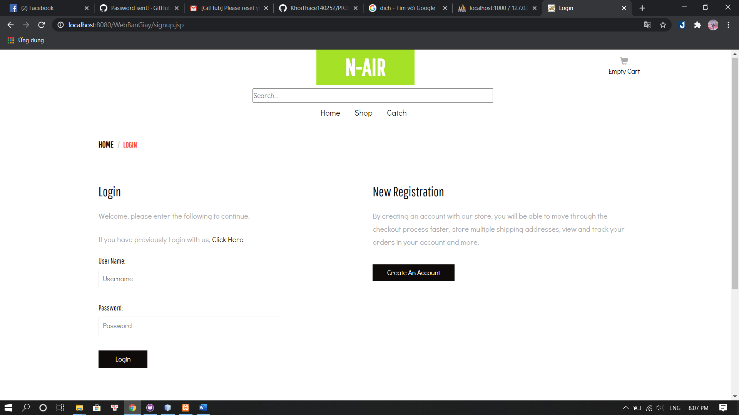

Figure 23: User- Login

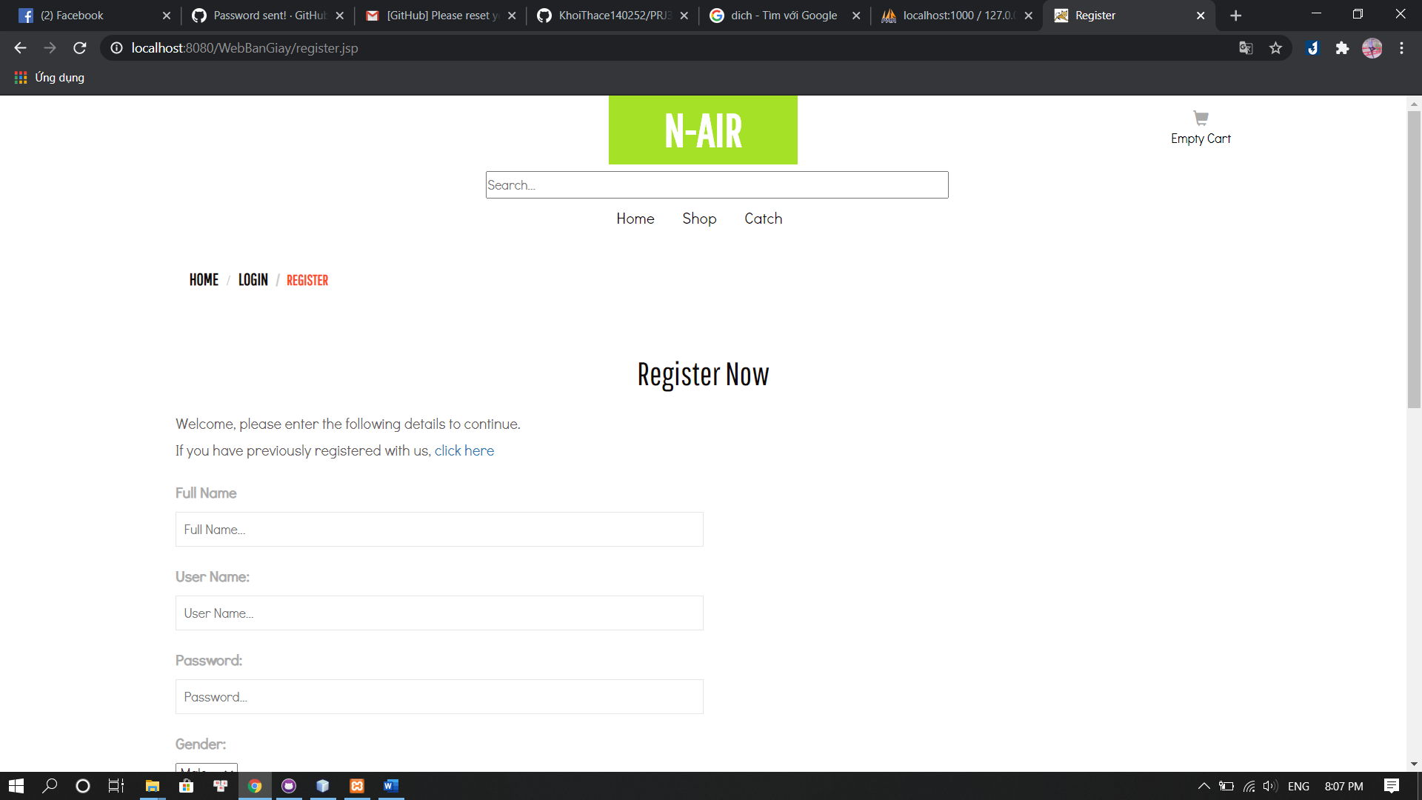

Figure 24: User- Register

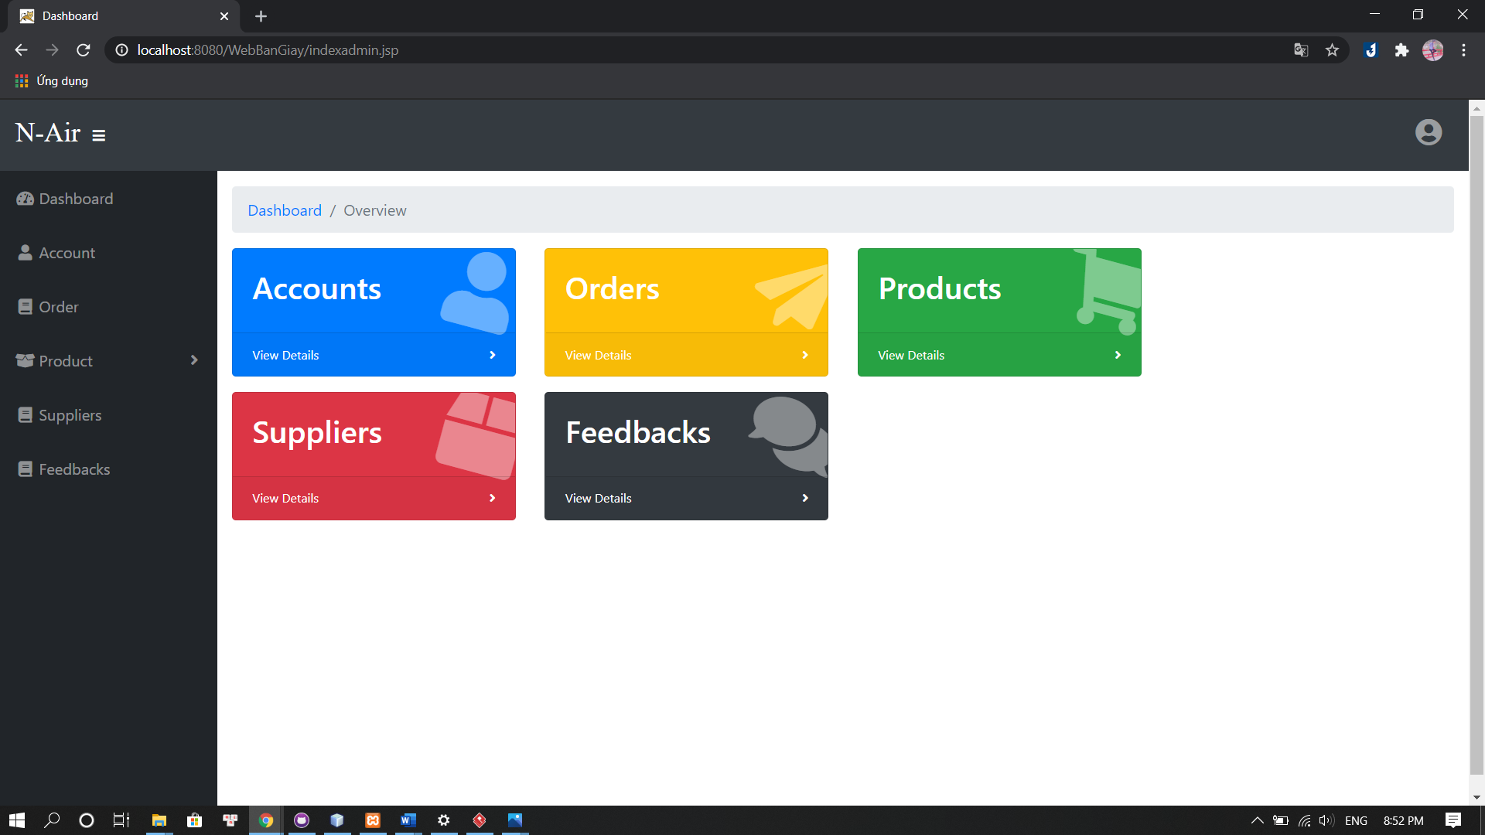

Figure 25: Admin- Dashboard

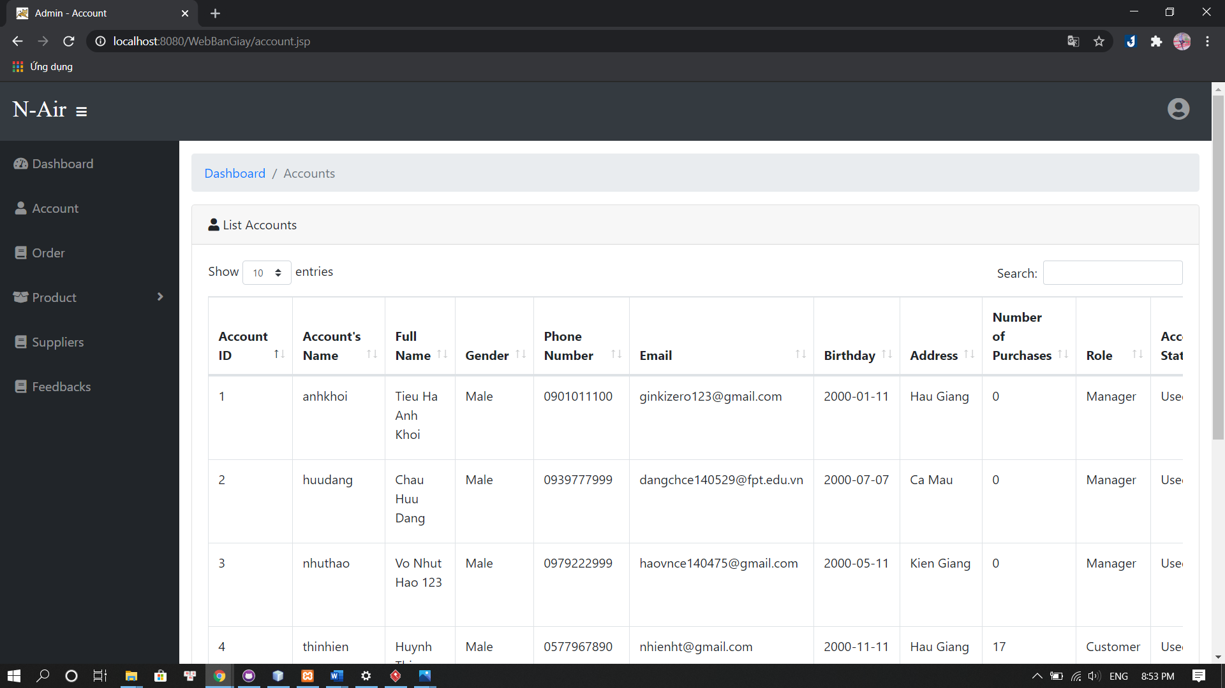

Figure 26: Admin- List Account

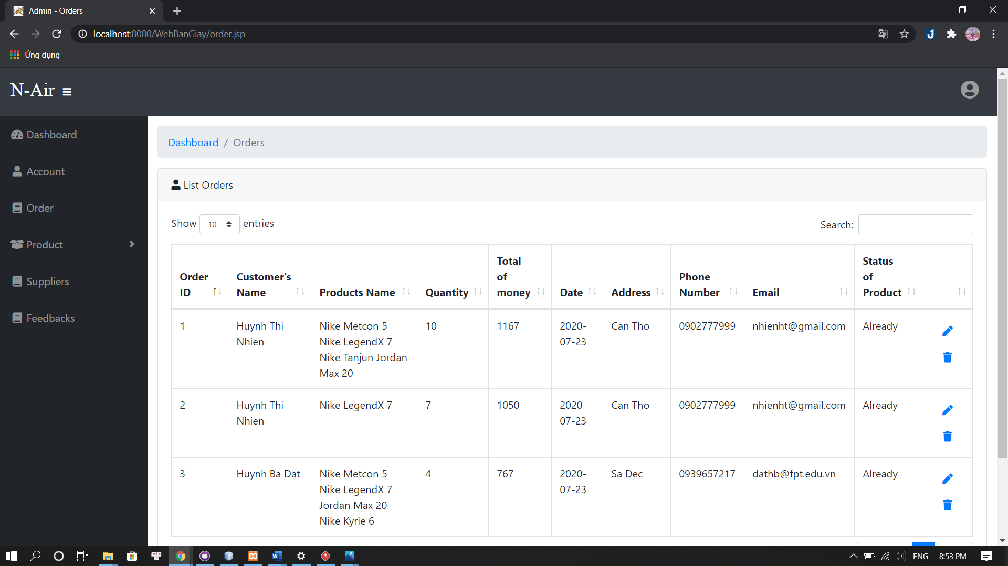

Figure 27: Admin- List Order

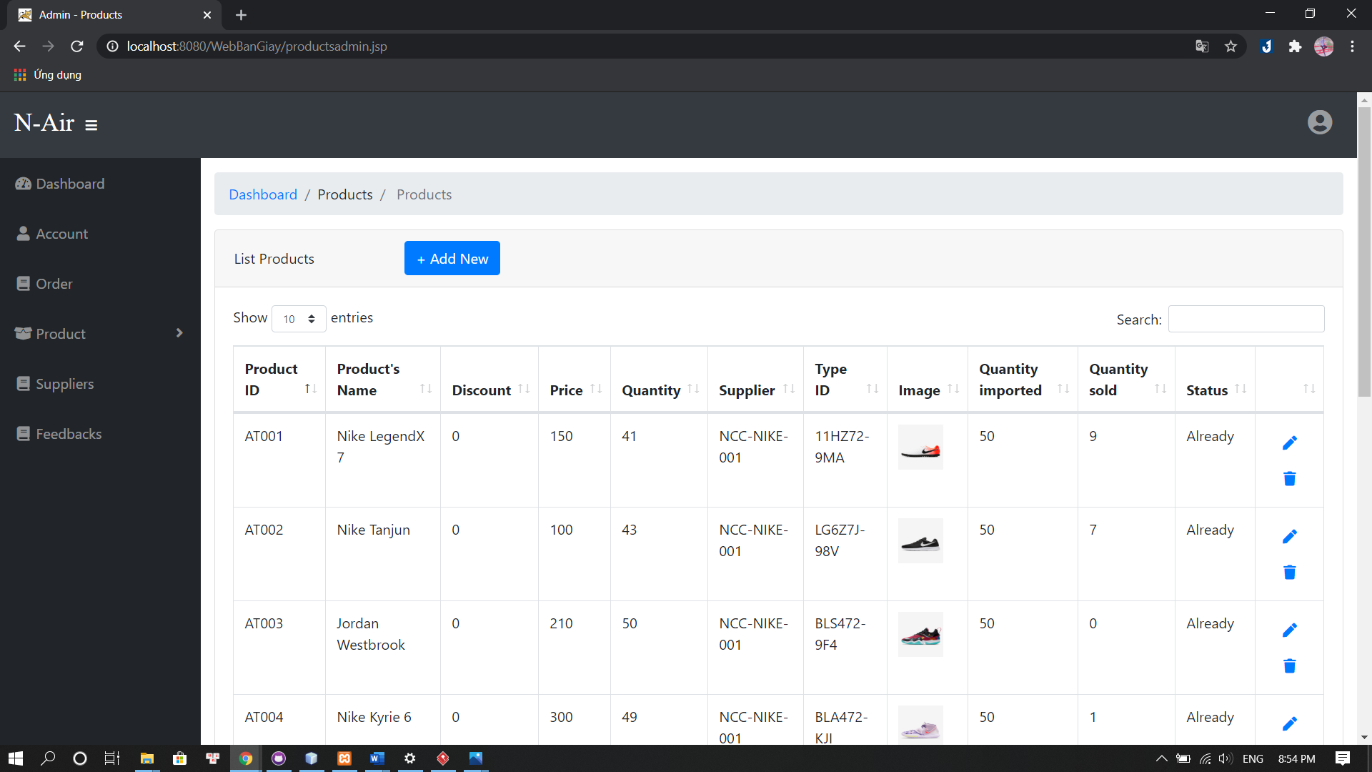

Figure 28: Admin- List Product

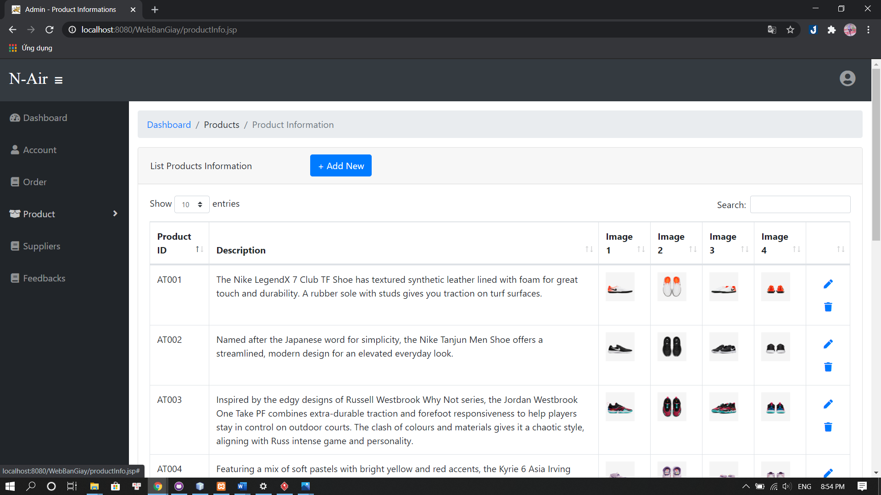

Figure 29: Admin- List Product Information

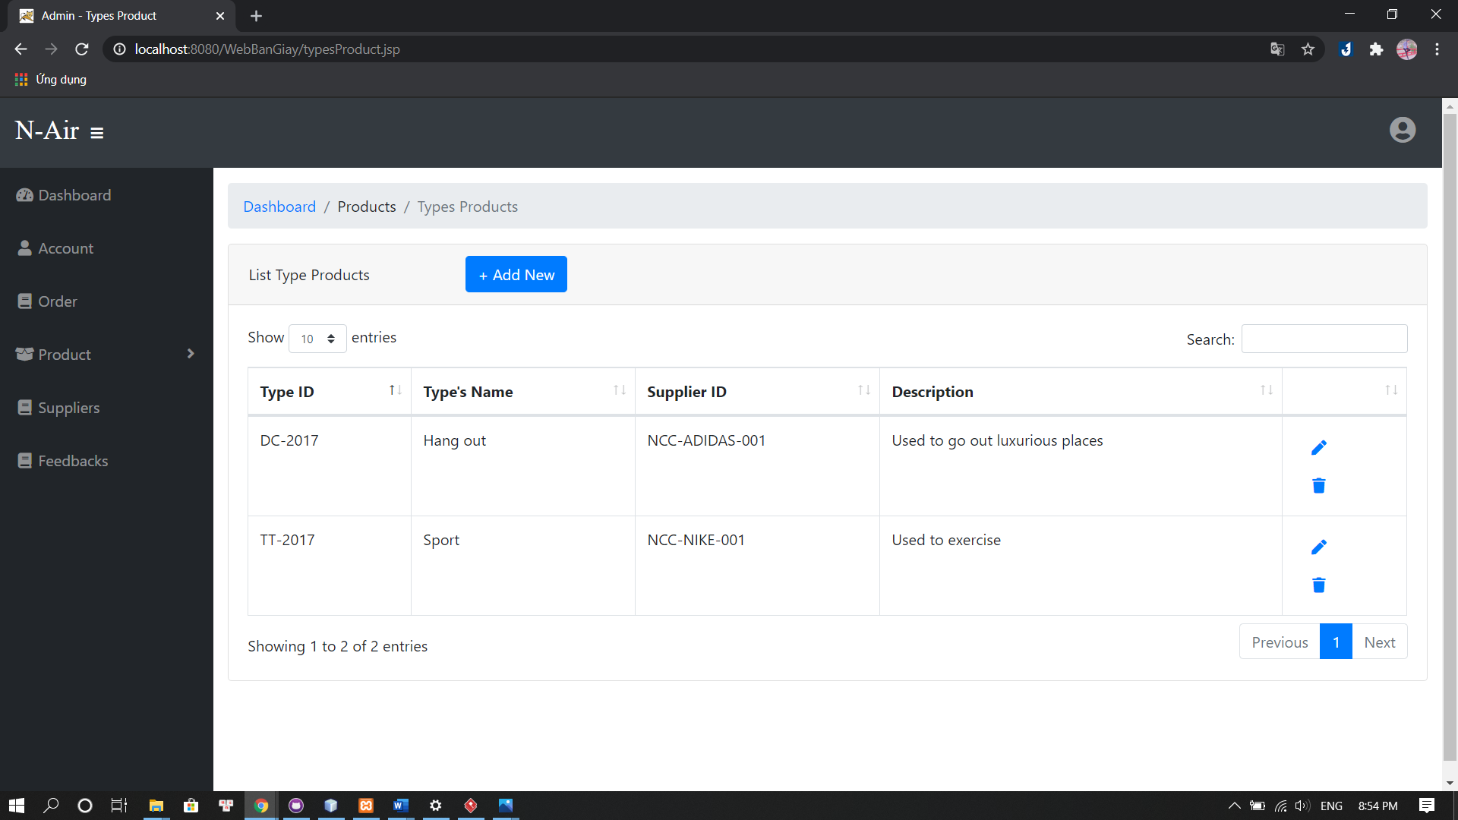

Figure 30: Admin- List Type Product

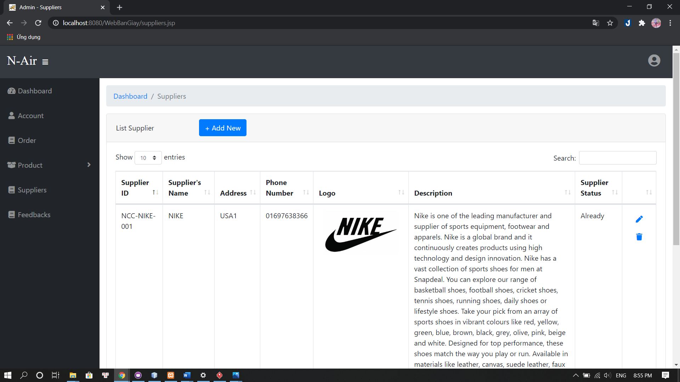

Figure 31: Admin- List Supplier

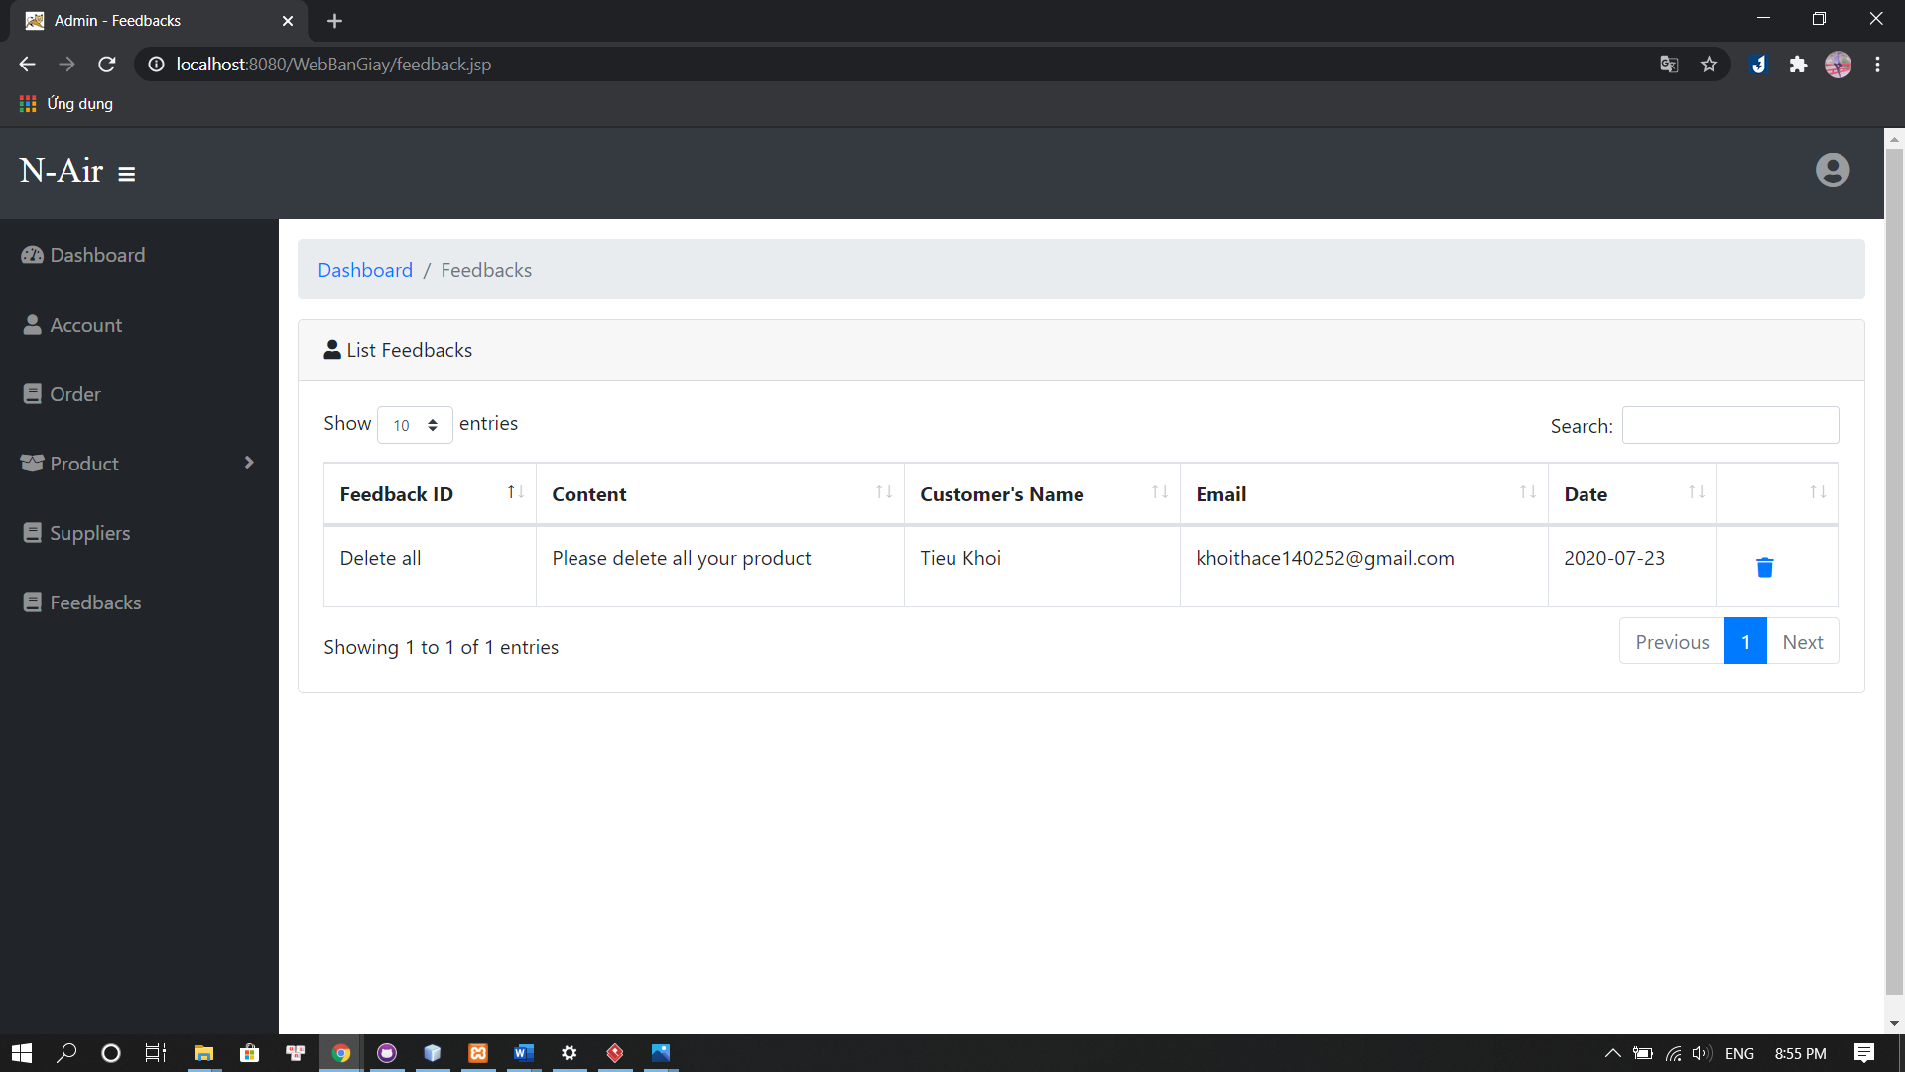

Figure 32: Admin- List Feedback

## 4.3 Flowchart

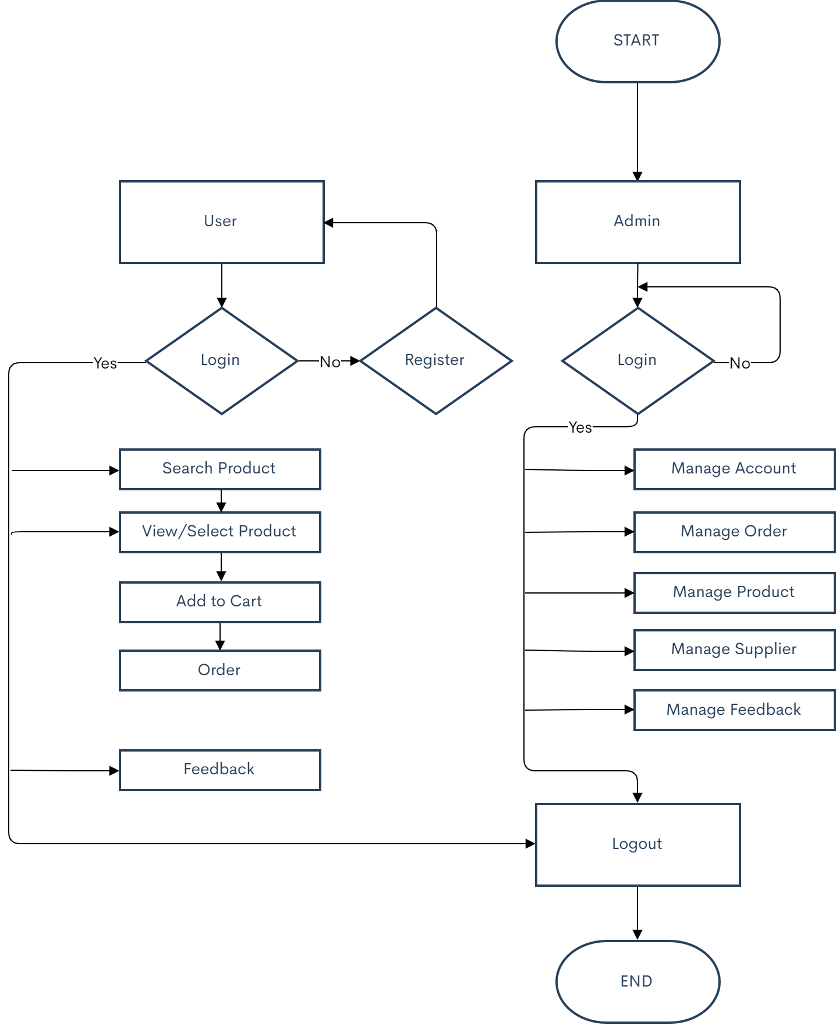

Figure 33: Flowchart Diagram

# CHAPTER 5: Consolution

## 5.1 The advantages of program:

### 5.1.1 About user:

* The methods of searching and searching by price, product lines combine many topics, many types of products according to customers.
* View detailed information about commercial products and full information of Nike shoe store.
* Allows registration information to view and purchase products.
* Check the validity of customer login information.
* Create an order.
* Can run on many browsers.

### 5.1.2 About admin:

* See information of items to be managed such as: Customers, products, orders
* Update or delete data
* Can run on many browsers.

## 5.2 The disadvantages of program

* The connection between server and database is slow
* This is obvious because the bridge settings must go through many levels. The only way is for the server to run on a machine with a strong configuration.

## 5.3 Development direction of the project

* The development direction of the website and the group is towards an e-commerce website with many convenient features and suitable for users. How to make the product stand out and be different from other websites.
* The main problem of the website is serving advertising. Since then, besides selling, it is also required to attract customers to design and install a software of a specialized field.
* Therefore, it is necessary to supplement the following functions: checking website visits, import and export statistics, inventory.
* Although we have tried to complete the requirements, the report still has many shortcomings looking forward to receiving the contributions of teachers, to help our website be more complete.